Business Law – Chapter 5

Federal Court System – Judicial Circuits

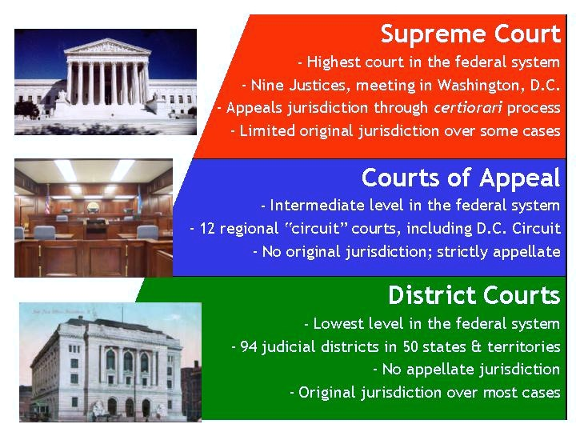
Federal Court System – Flow of Cases

